Brandon Lee  
14010627X  
11/12/14  
Assignment 2

*Complete project is included. Full working source code can be found there.*

**Problem 1 – Circular doubly linked List**

Program was run using given tests in main()

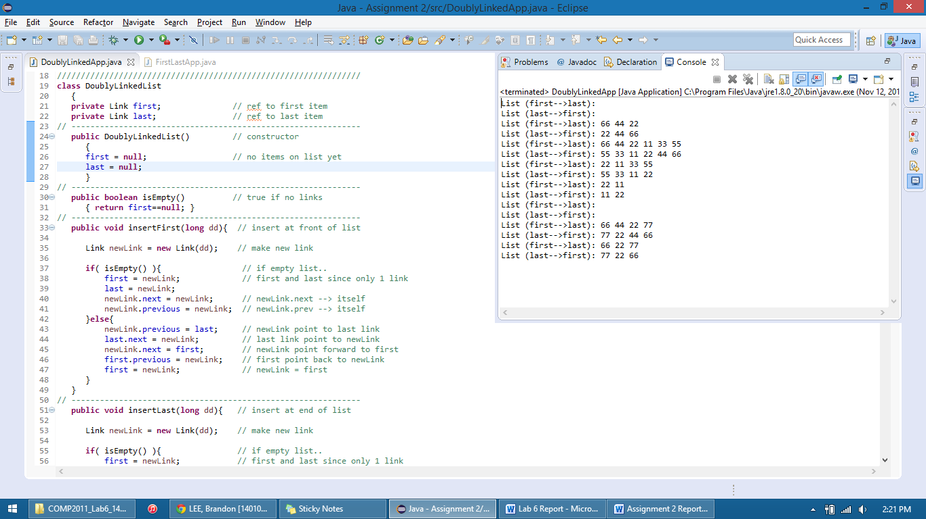

**Problem 2 –Remove Duplicates**

Program was run using given tests in main()

